Scan To Watch Our Company Profile

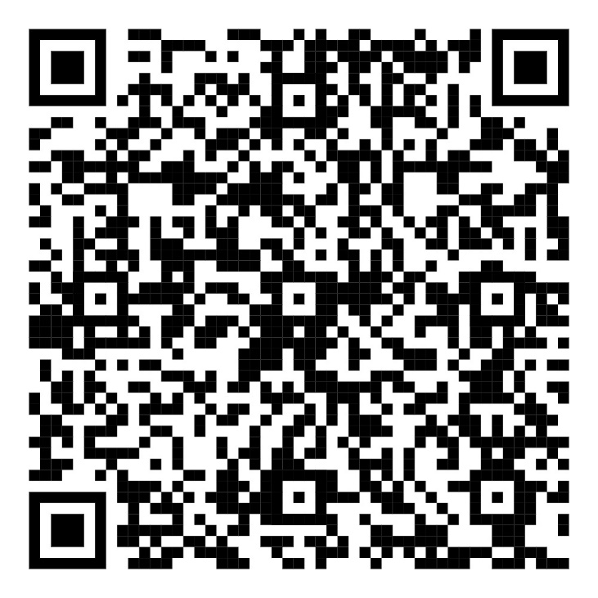

ESTSS: Where Safety Meets Expertise.

ENVIRONMENTAL SAFETY TECHNOLOGIES
FOR SPECIALIZED SERVICES CO.
7711 An Naisaburi St. - Al Athir District, (Dhahran Jubail Highway - Bin Hindi Tower – Office B108), Dammam, 32248 – 3030, Kingdom of Saudi Arabia
Tel.: +966 13 814-8420 | Fax: +966 13 814-8419

Company Profile
ESTSS Co. is a leading provider of Radiation Protection and Environmental Compliance Services based in Dammam, Saudi Arabia. With over 25 years of experience, we cater to a wide array of industries, including oil and gas, healthcare, laboratories, NDT companies, and government sectors. Our specialized services are tailored to meet the unique needs of each client, ensuring compliance with national and international regulatory standards.
Our comprehensive range of services in radiation protection includes TLD analysis, area surveys, wipe tests, quality control, Radiation Safety Officer (RSO) training, and transportation of hazardous materials. We also offer environmental compliance services such as permitting, consultations, and environmental measurements, supporting organizations in achieving and maintaining regulatory compliance.
Accredited by the Nuclear and Radiological Regulatory Commission (NRRC), National Center for Environmental Compliance (NCEC), and Saudi Food and Drug Authority (SFDA), we adhere to the highest standards of quality and safety. Our certifications include ISO 9001 for quality management, ISO 14001 for environmental management, and ISO 45001 for occupational health and safety management, demonstrating our commitment to excellence across all facets of our operations.
At ESTSS Co., we take pride in delivering reliable, high-quality services and solutions that contribute to the sustainability and success of our diverse clientele, including petroleum and petrochemical industries, government agencies, hospitals, and specialized laboratories.

ESTSS Co. Profile | Page 1 of 5
ESTSS’s Services include but are not limited to:
- Environmental Permitting, Consultations & Measurements.
- Consultation in the field of Occupational Safety, Health, Environmental and Inspection.
- Occupational Health Risk Assessments.
- Personal Thermoluminescent Dosimetry (TLD) Analysis.
- Wipe Test Analysis / Onsite Leak Testing.
- Area Survey of Radioactive Sources.
- Transportation of Radiation Sources and Custom Clearance Service.
- Radiation Safety Training Courses.
- Radiation Safety Officer (RSO) preparatory Course.
- Radiation Workers Safety Courses and Training.
- Radiation Protection Consultancy.
- Calibration of Radiation Meters though an approved 3rd party institution.
- Diagnostic Imaging Quality Control Survey for all types of X-ray producing Machines.
- X-ray Room Radiation Leakage Survey.
- Lead Apron, Gonad and Thyroid Shield Quality Control Certification Test.
- Nuclear Medicine Radiation Safety.
- Supply a wide-range of Environmental and Radiation detection and monitoring devices.

ESTSS Co. Profile | Page 2 of 5
ESTSS growth is built on a diverse customer base; it includes over 300 organizations comprising of national and international companies, including but not limited to:
- Petroleum and Petrochemicals:
  - Saudi Arabian Basic Industries Corporation (SABIC).
  - Advanced Petrochemical.
  - Sadara Chemical Co.
  - Saudi International Petrochemical Co.
  - Petrol and Petrochemical (PETROCHEM).
  - Sahara Petrochemicals Co.
  - Farabi Petrochemical Co.
  - Saudi International Petrochemical Co.
  - Saudi Aramco Refinery, Ras Tanura.
  - Saudi Ethylene & Polyethylene Co. TASNEE.
  - Saudi Int’l Petrochemical Co. (SIPCHEM).
- Government Agencies/Facilities:
  - King Abdul-Aziz Naval Base (KANB), Jubail.
  - King Abdul-Aziz Air Base Hospital (KAAH), Dhahran.
  - Najran Armed Forces Hospital.
  - King Fahad Specialist Hospital, Dammam.
  - King Abdul Aziz Port Clinic, Dammam.
  - King Fahd Military Medical Complex.
  - Ministry of Health (MOH).
  - King Faisal Specialist Hospital (KKFSH) & and Research Centre, Jeddah Branch.
  - King Fahad University Hospital, Al Khobar.
  - King Faisal University, Al-Hasa.
  - El-Ghad International Colleges for Health Sciences.
  - Saudi Electricity Co. (SECO).

ESTSS Co. Profile | Page 3 of 5
- Non-Destructive Testing(NDT):
  - Fugro-Suhaimi Ltd. Co.
  - Al Hoty Stanger Ltd Co.
  - Gulf Engineering House (GEH).
  - AL-Mutawa Samyong NDT Co. Ltd. (AMSYCO).
  - NDT & Corrosion Control Svcs (NDT & CCS) Co., KSA.
  - KNDT Arabia Co. Ltd.
  - Rabigh for Industrial Insp. Co. (RNDT).
  - Rawabi Industrial Support Services (RISS).
  - Abdulla Nass & Partners Co. Ltd. (ANP).
  - Arabian CBI Co. Ltd.
- GCC Clients:
  - GIS Mutawa Inspection Services LLC, Abu Dhabi, U.A.E.
  - Global Inspection Services W.L.L. (GIS), Doha, Qatar.
  - Gulf Advanced Trading Co., Kuwait.
  - Qatar National Cement Co. (QNCD), Qatar.
  - NDT & Corrosion Control Services (NDT & CCS), UAE.
  - Al Hoty Analytical Services, Manama, Bahrain.
  - Hal Services LLC Co., Sultanate of Oman.
  - JV The Arab Contractors & Alwatanayah United, Oman.
  - Ruwais Fertilizer Industries (FERTIL), Abu Dhabi, UAE.
  - Sievert International Inspection Co WLL - Doha Qatar.
  - Stork Cooperheat Saudi Arabia Co. (COOPERHEAT) UAE.

- Industry Clients:
  - Arab Paper Manufacturing Co. (WARAQ).
  - Arabian pipes co. (APC).
  - Arabian CBI Co. Ltd.
ESTSS Co. Profile | Page 4 of 5

  - DJC Engineering and Inspection Services (DUR'AT).
  - National Titanium Dioxide Co. (Cristal).
  - Abdulla Fouad Holding Co.
  - Stork Cooperheat Saudi Arabia Co. Jubail, KSA.
- Health Care Facilities:
  - Al Mouwasat Hospitals.
  - Almana Group of Hospitals
  - King Fahad Specialist Hospital, Dammam.
  - Khafji National Hospital.
  - Al Ahsa Medical Services Company.
  - Alhammadi Hospital – Riyadh.
  - Alhokail Orthodontic Centers.
  - As Salama Hospital.

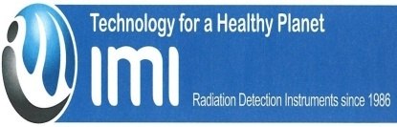

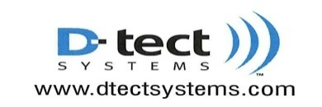
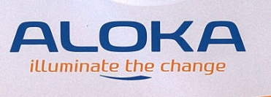


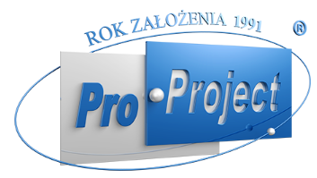

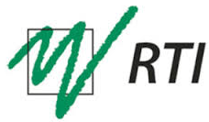
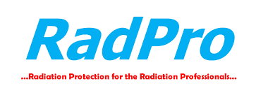
Company / Products we represent:

ESTSS Co. Profile | Page 5 of 5

